Query Builder

Contents

1. Introduction 1

2. Main program 2

3. Add New Query 3

4. Run query – full screen 4

5. Modify Query 5

6. Edit query – Properties 6

7. Edit query – Tables 7

8. Edit query – Relations 8

9. Edit query – Conditions 9

10. Edit query – Fields 10

11. Edit query – Results 11

12. Screens for admins 12

13. Settings 13

14. Notes 14

## Introduction

This document describes a possible implementation of the QueryBuilder for Advantzware. It is not meant to be a final document, but it serves as a discussion document to see whether all involved are on the same page. Screenshots are therefore created with a drawing tool to emphasize its provisional character. The document will be updated during the project.

## Main program

The main program is a standalone program (that is: no parameters) that can be called from the Advantzware menu. Authorization for the QueryBuilder should be arranged in Advantzware. When the user (any user) starts the program, he or she will see a screen with his personal queries. This screen will look something like this:

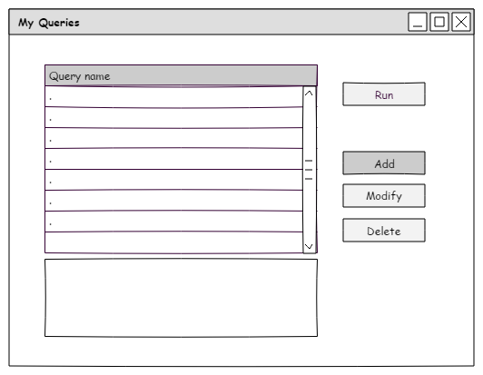

When the user starts the screen for the first time, there will be no queries. Since there is nothing yet, the buttons for Run, Modify and Delete are disabled. The only valid choice here is to add a query.

## Add New Query

When the user clicks ‘Add’, depending on his role, he will see a different screen. A ‘normal’ user will only be able to select from a list of predefined queries and will see this:

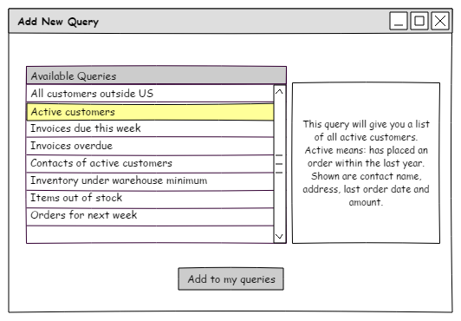

Here, only predefined queries are shown and the user can select one. In the box at the right a description is shown about the query. When the user confirms his choice, he will go back to the first screen, where the chosen query is now the only one in the screen:

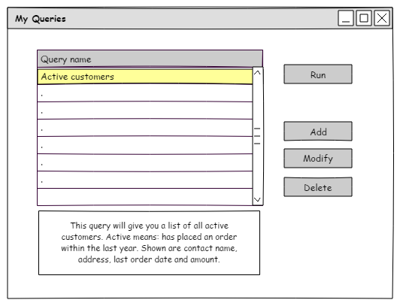

Now, with at least one query, all buttons are sensitive, and the user can choose to either add more queries, run the query directly or modify it.

## Run query – full screen

Running the query will result in a new screen, where the results of the query are shown full screen:

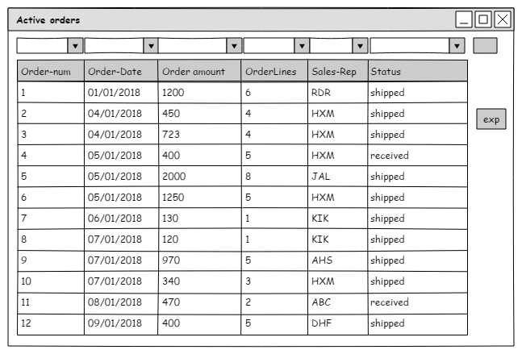

The screen is resizable and shows filter boxes á la DataDigger. With these, the user can filter the outcome. With the ‘Exp’ button, the data can be exported to HTML, Excel or plain TXT.

## Modify Query

When the user chooses to modify the query, his role will determine how the screen will look.

Admins and super admins will see a version with additional tabs at the left. These extra tabs are needed to define the query.

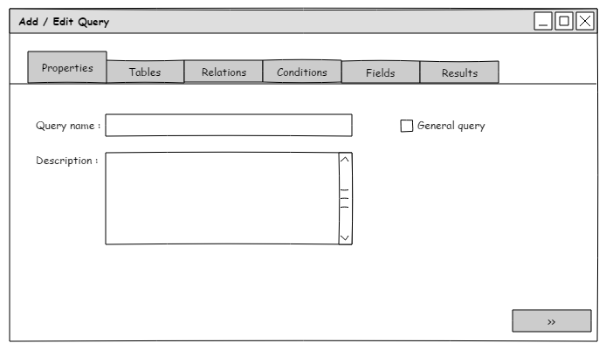

On this screen, depending on his rights, the admin can create or modify the query and optionally test it to fix errors. A normal user will see a trimmed down version with three tabs:

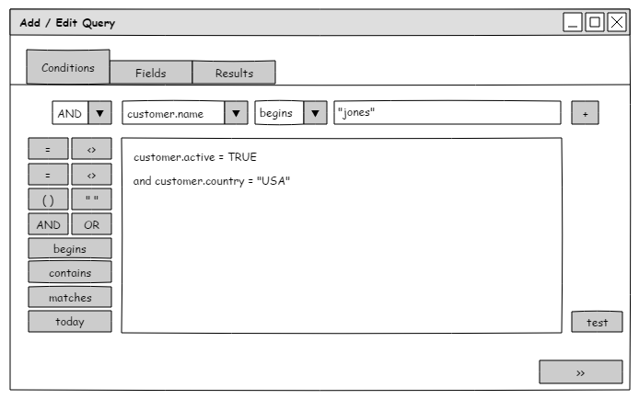

And will jump straight to the ‘Conditions’ tab.

## Edit query – Properties

This tab is for admins only and it allows them to define a name and description for a new query or change it for an existing one.



In the properties tab, the query name can be defined. This name is shown in the browse with queries for all users. The description is also shown in that screen, in the box beneath the browse. A toggle box in this screen can indicate that the query is a predefined one. Queries that are marked as general are the queries that can be chosen by normal users.

A typical use for an admin to **not** check this box would be when they make queries for themselves and when they do not want that query to be available for normal users.

## Edit query – Tables

The tab “Tables” is the tab where the tables are selected for the query:

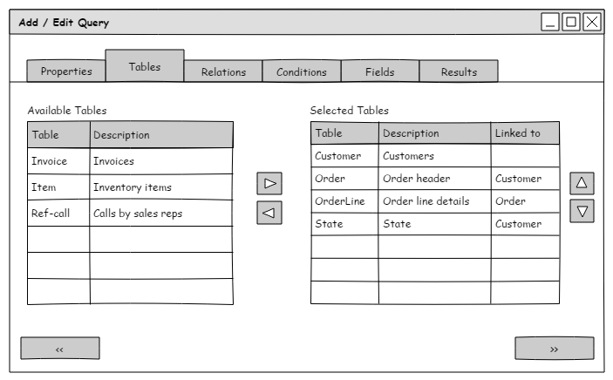

Here, the tables to include can be selected by using the horizontal arrow buttons to ‘shoot’ tables from left to right. Left browse shows all available tables and the right browse shows the ones that are chosen for this query. Normal admins can only see the tables that are defined by a super admin.

The QueryBuilder can automatically detect how the tables can be linked and will show that in the last column of the right side browse. If the admin wishes, he can change that in the ‘Relations’ tab.

## Edit query – Relations

Tab “relations” can be used to further specify the relation between tables:

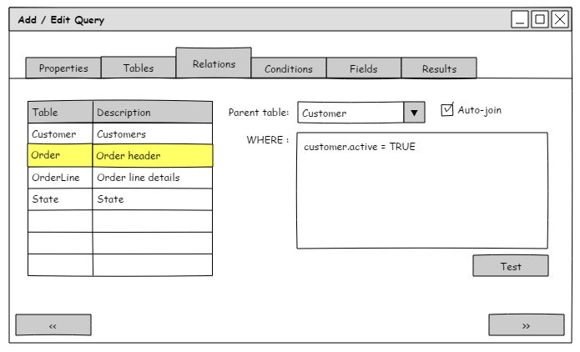

In this screen, only the tables that were chosen in the previous tab are shown. In the example above, the Order table is selected. It is linked to the customer table. The combo box only shows tables of the query that are higher than the currently selected one in the browse. For the first table this means that it is not linked since there are no tables ‘above’ it. The second table can only be linked to the first one and the third can be linked to either the first one or the second.

In the example, the toggle for “Auto-join” is checked. This means that the relation is defined by Progress through an ‘OF’ condition in the query using indexes. A query with an auto-join would look something like:

FOR EACH customer, EACH order OF customer.

Note that the fields used in the indexes determine whether this is possible or not. The relation can also be defined / further refined by using a where phrase. In the above example, we let Progress determine the relation, but further limit the relation by only allowing active customers. The query will look like:

FOR EACH customer, EACH order OF customer WHERE customer.active = TRUE.

The ‘Test’ button can tell the admin whether he is on the right track or not.

## Edit query – Conditions

On the fields-tab, the user can select the fields to show. Note that the screenshot below is the way a non-admin will see the screen. An admin would also see the Properties, Tables and Relations tabs.



This screen works similar to the screen found in DataDigger. It enables the user to build a where-phrase using the combo boxes at the top or by typing directly in the editor. The query can be tested via the Test-button.

## Edit query – Fields

The fields tab enables the user to finetune the fields that must be shown in the results:

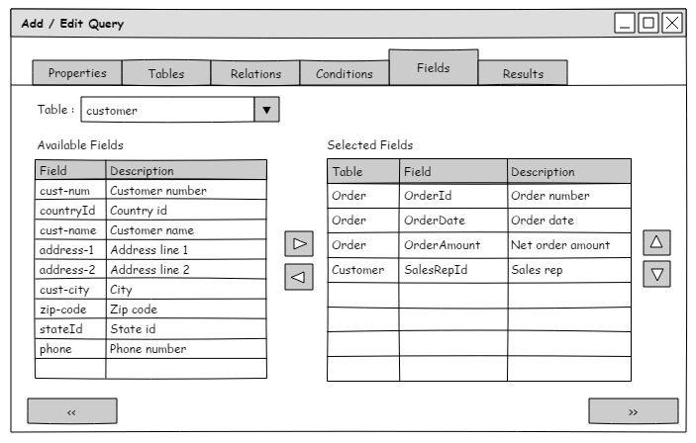

At the top a combo box enables the user to narrow the list of fields to those of one table. Only the tables that are used in the query are in this combo box. The left browse shows all fields from the selected table (except fields that are explicitly hidden by a super admin). A field can be added to or removed from the query using the arrow-buttons between the two browsers. The right browser shows the fields that are selected. The order of the fields can be arranged using the arrow-buttons at the right.

## Edit query – Results

The results tab shows a smaller version of the full screen variant:

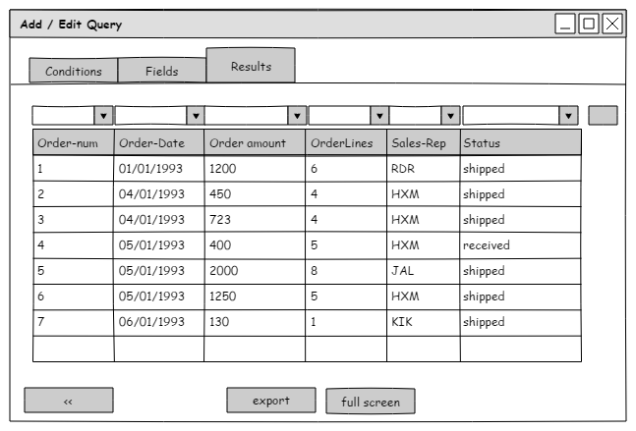

Here, the user can see a smaller subset of the query, but he can choose to switch to full screen when desired or export the records.

Note that batch sizes can be arranges through a simple, yet powerful mechanism. When the user opens the query, initially only the first 50 records are shown that satisfy the query. To indicate that the query is not complete, a red line is drawn around the browse. When the user clicks the ‘filter’ button again with the same filter criteria, the number of results is multiplied with ten. So this could be a realistic scenario:

1. User opens the query screen
2. User presses ‘run’
3. Query is shown full screen with max 50 records
4. User presses filter button
5. Query is re-opened and shows max 500 records
6. User presses filter button again
7. Query is re-opened and shows max 5000 records
8. User changes filter values and presses filter button
9. Query is re-opened and shows max 50 records

Although this may look complicated, in practice it is extremely easy to grasp for a user. The red lines are also used by DataDigger, although in a slightly different way. DataDigger tries to grab as many records as possible in a limited amount of time.

## Screens for admins

For admins and super admins, the flow of screens is slightly different. They have more choices, but their initial screen is the same:



The reason is that an admin or super admin can have queries of their own as well as modify the predefined queries. The Run button will have the same result as the one for normal users, but the Add and Modify button both bring the (super) admin to the tabbed screen where he has a few more options. Note that ‘Add’ for a normal user will bring up the selection screen with predefined queries.

## Settings

The settings could be made available via an extra tab with settings. This tab would only be visible for super admins and would contain settings for the QueryBuilder. Settings include hidden tables and fields and initial batch size and increase factor on repeated queries.

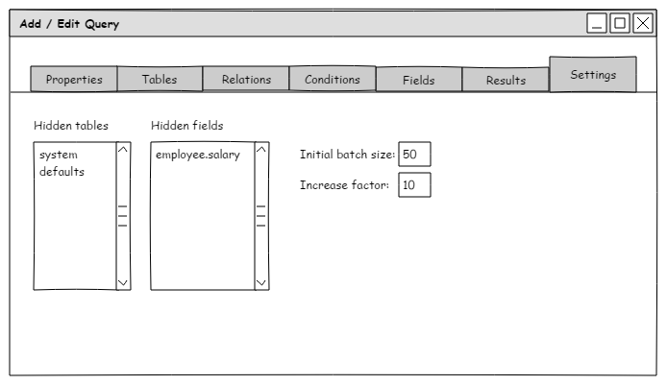

In this example, admins and users would not be able to see the tables ‘system’ and ‘defaults’ and their fields, nor create queries that use these tables. Field ‘salary’ on the employees table would also not be available.

The initial nr of records that a user would see is 50. Each time the query is repeated, this is increased with factor 10.

A limit to the number of tables in a query is not needed. Progress can handle up to 18 tables in one query, but since only admins can create new queries, I don’t see no real need to limit this. If you do want to limit it, this would be the screen to set it.

## Notes

Some notes on the screens as described above.

* Tables and fields that are hidden, are not visible for normal users and admins
* When a table is part of a query, but is later added to the list of hidden tables or fields, it ‘disappears’ from existing queries. In the case of tables, this may corrupt a query. Super admins should be aware of that.
* Defining which user is in the ‘Normal user’ group or in the ‘admin’ or ‘super admin’ group is done via normal AdvantzWare functionality.
* Full screen with results is resizable, columns are resizable.
* Export is to Excel, HTML or TXT format